Topic: Traveling
Form: 10th
Level: B2
Time: 45 minutes
Aim: to develop students’ reading skills on the basis of text;
Learning outcomes: By the end of the lesson, the learners will be able to read for specific information and summarize key facts about Victoria Falls.
Teaching aids and materials: a laptop, an interactive whiteboard, pictures, handouts, pens.
Warm-up activity (5 min)
Ex.1 Close your eyes. Listen to the sound and imagine you are really there. Make a Mind Map – “My Five Senses”. Share with a shoulder partner.
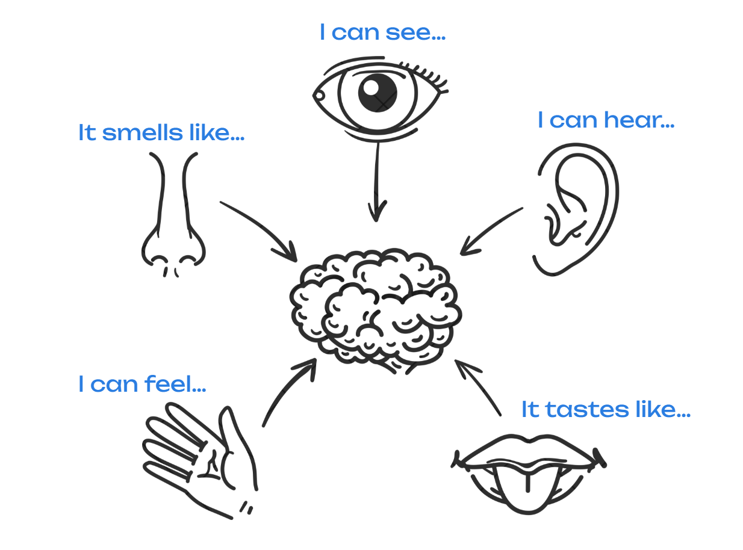
Pronunciation warm-up (3 min): Tongue Twister

'Those three thoughtful tourists threw their things into the thick path'

Main Part (30 min):
Ex. 1 You are going to read the text «The Thundering Smoke». Look at the words, discuss the meaning and predict what the text might be about.
🔹thunder 🔹plunge into 🔹 natural wonders 🔹 rainbows 🔹 unique experience 🔹 tourist attraction 🔹 named

Ex. 2 Divide into 4 groups: A, B, C, D. Each group reads their part of the text.
Group A: Africa before exploration
Before the exploration of Africa in the 19th century, myths and legends circulated around Europe about the mysterious continent. Europeans knew very little about this vast mass of land, as only a few brave travellers had ever dared to venture deep into its interior. Many people imagined Africa as a land of danger, wild animals, and untold secrets.
One enthusiastic Scottish explorer, Dr David Livingstone, was especially passionate about Africa and extremely eager to discover its wonders. His dream was not only to explore, but also to help local communities and to share knowledge about the continent with the rest of the world.

Group B: Dr Livingstone’s journey
Dr Livingstone was sent to South Africa in 1840 as a medical missionary. He spent more than thirty years of his life there, travelling across difficult terrain, facing tropical diseases, and discovering places that no European had seen before. Between 1842 and 1846, he explored large areas of south and central Africa and became the first European to travel across the entire region from west to east.
On 16th November 1855, during one of his journeys, Dr Livingstone stumbled upon a breathtaking sight - a massive waterfall unlike anything he had ever seen. “No one can imagine the beauty of the view from anything witnessed in England,” he wrote in his diary. “It had never been seen before by European eyes; but scenes so lovely must have been gazed upon by angels in flight.”
Deeply impressed, Livingstone decided to name the falls Victoria Falls in honour of Queen Victoria, who was ruling Britain at that time.
Group C: Facts about Victoria Falls
Today, Victoria Falls is located in the national park of the same name, on the border between Zambia and Zimbabwe in southern Africa. The local people call it “Mosi-oa-Tunya” — “The Smoke That Thunders” — because of the loud sound of the falling water and the great mist that rises into the sky.
While it is neither the highest nor the widest waterfall in the world, it is the largest. The falls themselves are 1,708 metres wide and 108 metres high. Every single minute, about 500 million litres of water plunge into a deep gorge below, creating a roaring sound that can be heard from kilometres away. The powerful spray rises up to 400 metres and can sometimes be seen from 50 kilometres away.
Group D: Why it is a world wonder
The waterfall is undoubtedly one of the most magnificent natural spectacles on Earth. Victoria Falls is considered one of the seven natural wonders of the world, and the entire national park is a UNESCO World Heritage Site. Visiting it is a truly unique experience — the noise of the water sounds like thunder, and the air above the falls is filled with fine mist, like clouds of smoke.
On sunny days, spectacular rainbows appear across the water, making the scene even more magical. The area around the falls is home to tropical forests, colourful birds, and exotic animals, all of which add to its beauty and magnificence.
Standing in front of Victoria Falls today, visitors feel the same sense of wonder and admiration that Dr Livingstone experienced more than 150 years ago. It remains a symbol of nature’s power and an unforgettable tourist attraction that draws thousands of travellers from all around the world.
Ex. 3 Exchange the Information. Form new groups (A + B + C + D together). Tell your group what you learned about your part. Listen to others and complete your notes so you know the full story of Victoria Falls.

Ex.4 Scan the Qr code. Read the statements and decide if they are True (T) or False (F) according to the text.
Ex.5 In your own words, and based on the text, answer the questions.
      - Who was Dr David Livingstone?
      - When and where did he discover Victoria Falls?
      - What does the local name “Mosi-oa-Tunya” mean?
      - Why did Livingstone name the falls after Queen Victoria?
      - What can visitors see and hear when they come to the falls today?
Ex.6 Imagine you are Dr Livingstone and you are seeing the Falls for the first time. In three minutes write a few sentences describing your experience and feelings. Use AI to bring your story to life.
Reflection (2 min)
Evaluation and Assessment (2 min)

Homework (2 min): Find information about another famous waterfall in the world (e.g., Niagara Falls, Iguazu Falls, Angel Falls). Write 5–6 facts about it (location, height, interesting legend, fun fact).

Topic: Past adventures
Form: 10th
Level: B2

Aim: To develop students’ speaking and writing skills through storytelling about past travel experiences.

Learning Outcomes: By the end of the lesson, learners will be able to:
- Describe their past travel experiences.
- Identify and correctly use different past tenses (Past Simple, Past Continuous, Past Perfect) in context.
- Collaborate in groups to create and present short stories.
- Use AI tools creatively to visualize and present information about their travel experiences .
Teaching aids and materials: a laptop, an interactive whiteboard, SB On Screen B2, cards with countries, Sorywizard AI, pictures for group-up activity, blanks for evaluation
Warm-up (5min):
1. Take one card with a country. Choose a city in that country and ask Leonardo.AI (https://leonardo.ai/) to generate a picture of the city.
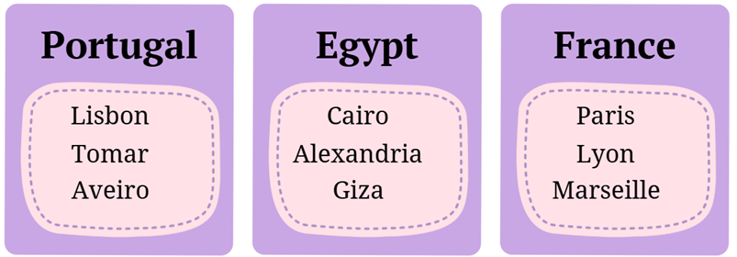
2. Last summer you went to that city. Tell us:
- Where did you go?
- What did you see?
- What did you eat?
- Do you recommend going there?
E.g.: Last summer I went to London. I saw many famous places like Buckingham Palace, Big Ben, and the London Eye. I tried traditional English breakfast and some fish and chips. I’d definitely recommend visitingthis city, there’s always something to see or do.
Checking homework (2 min)
Phonetic drill (3 min):
3. Read the tongue-twister. Focus on the endings (-ed).
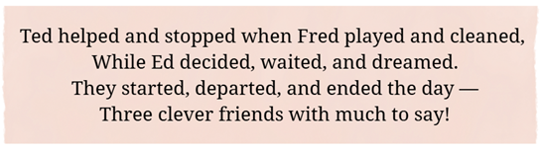

Main part (30 min):
4. Read the text. Look at the verbs in bold and say what tense they are. Match them with their uses. (5 min)
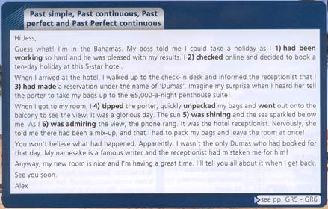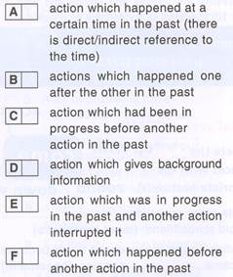

5. Put the verbs in brackets into the correct past tense to complete the dialogue. Explain your answers. (5 min)
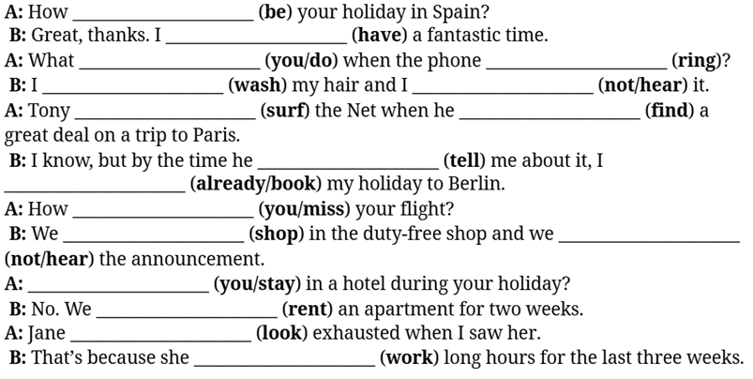
6. Group up. Group 1 - you’ve had a great trip, Group 2 - your trip failed, Group 3 - your trip was fine, but you wouldn't go there again) (2 min)



7. Follow the link https://www.storywizard.ai/ or scan the QR-code. Tell StoryWizardt a story (6-7 sentences) of your trip using past tenses. Generate the full story and pictures for it (8 min)

E.g.: Last year, my friends and I planned a trip to Paraguay, but everything went wrong. First, our flight was delayed for ten hours because of a storm. When we finally arrived…
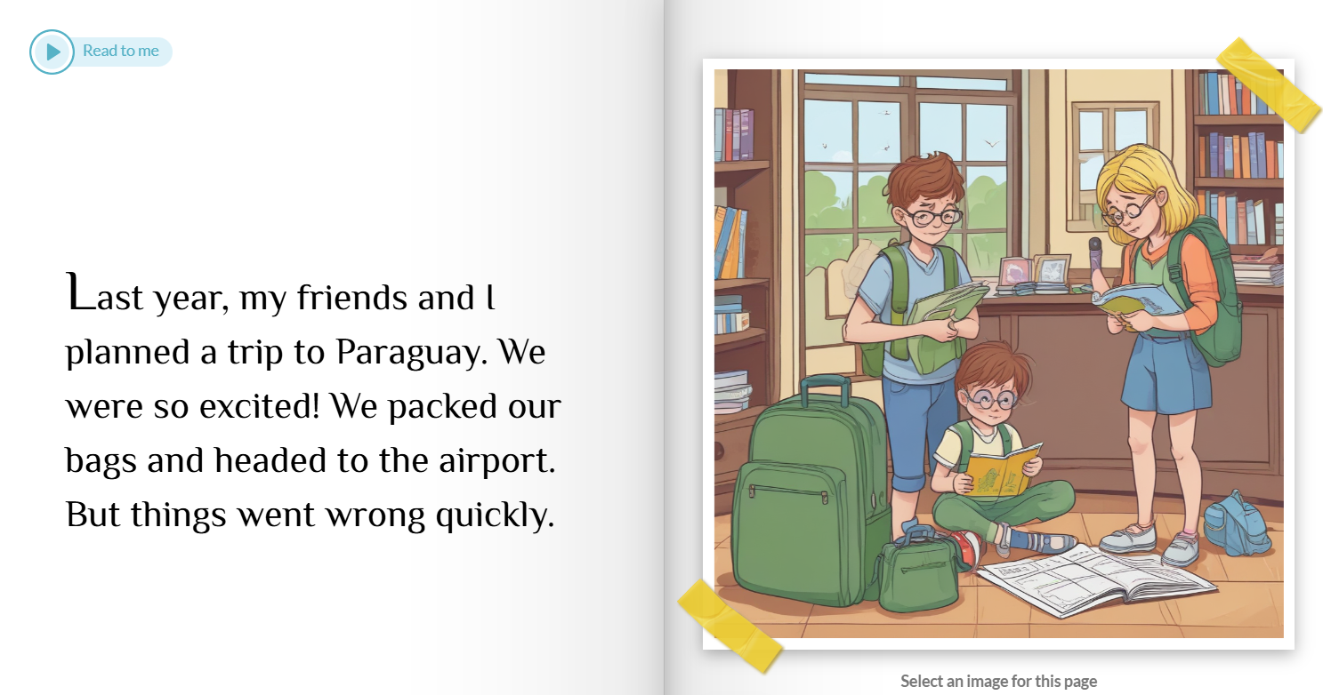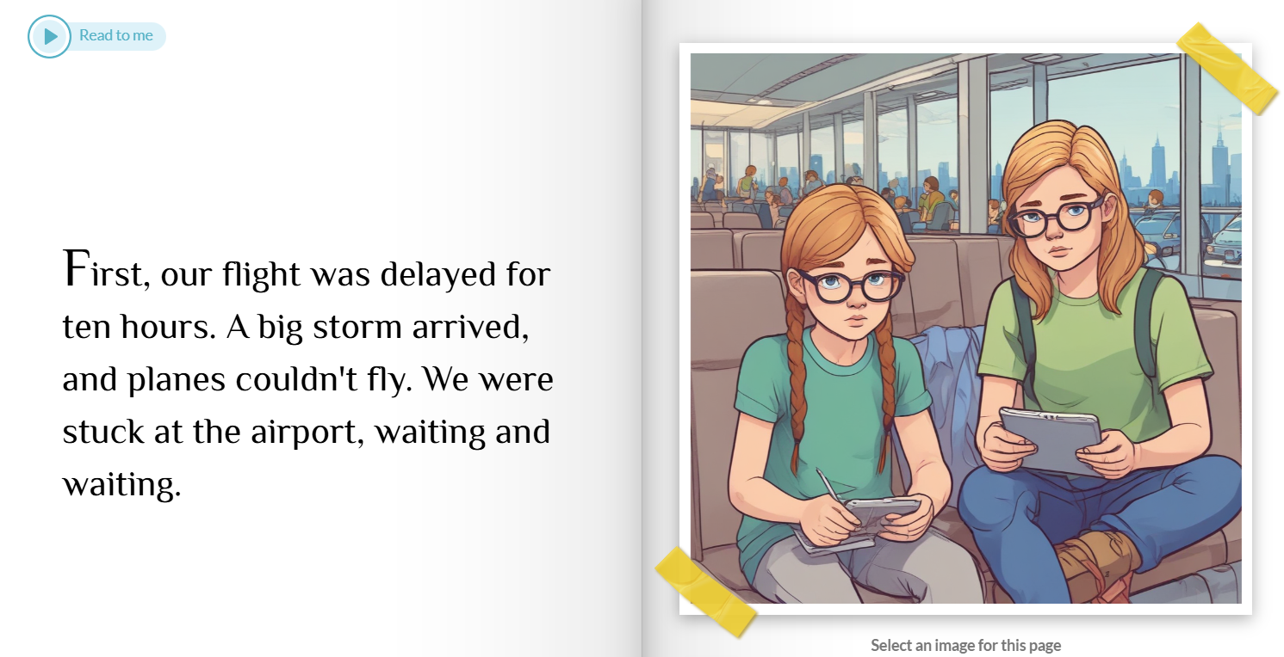
8. Show your pictures to the other groups and let them guess what happened in your story. (3 min)
9. Present your stories to the whole class. Choose a number from 1 to 5 to show how much you agree or disagree. 1 means"I don't agree at all" and 5 means"I totally agree" (7 min)
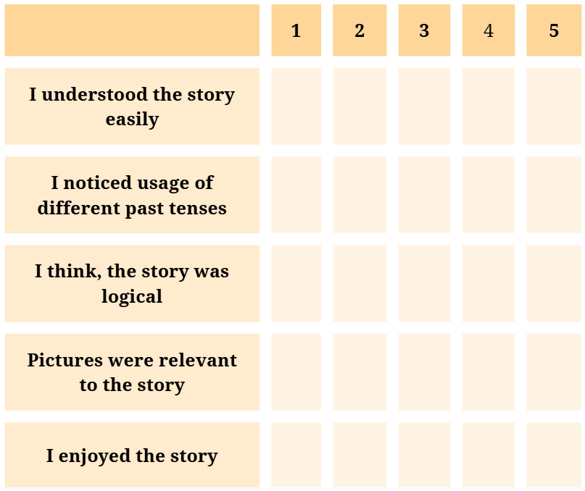
10. Assessment and evaluation (2 min)
11. Homework (3 min) Write a short essay (10-15 sentences) about the best trip in your life. Use as many past tenses as you can.

Topic: Holiday problems
Form: 10th
Level: B2

Aim: to develop students’ oral interaction and listening comprehension skills for understanding details and specific information about holiday problems.

Learning Outcomes: By the end of the lesson, learners will be able to:
- Identify and understand specific information about holiday problems in a listening text.
- Interact orally to share and discuss their own or others’ holiday problems using topical vocabulary.
- Predict and summarize events in a listening text.
- Apply AI tools creatively to visualize and present information about travel experiences.
Teaching aids and materials: a laptop, an interactive whiteboard, box, SB On Screen B2 (Unit 3d p. 44), audio recordings to the book, QR codes to AI Image Generator and Diagram Generator AI
Warm-up: Agree or Disagree (5m)
Read each statement. Do you agree or disagree? Explain why.
- Travelling is the best way to learn about other cultures.
- It’s better to travel with friends than alone.
- Holidays at the beach are boring.
- You don’t need a lot of money to travel and have fun.
- Travelling by plane is the most comfortable way to travel.
- Visiting new countries helps you become more confident.
- It’s more interesting to visit small towns than big cities.
- Taking photos is the most important part of travelling.
- Travelling can sometimes be stressful and tiring.
- Everyone should travel abroad at least once in their life.
Checking homework (2 min)
Phonetic drill (5 min)
Audio:https://drive.google.com/file/d/15VvCfvk77TQnQrzKTtupOZbLmz0dtfDw/view?usp=sharing

Listen to the sentences. Highlight which syllable is stressed in each sentence. Listen again and repeat.
- What bad weather!
- How terrible!
- How disappointing!
- What an awful experience!
- How exhilarating it must have been!
Checking homework (2 min)
Pre listening prediction anticipation ( 8m)
Take a piece of paper with holiday problems from the box and keep it secret. Scan QR code to generate an image which reflects your holiday problems. Share your image with others that they can guess what problem is presented. Take turns.
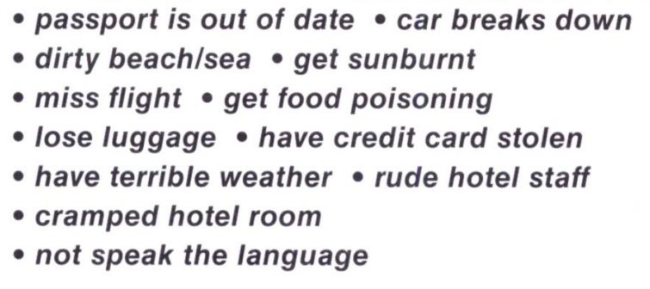
 AI Image Generator
Interrupted case for listening (13 m) Audio:https://drive.google.com/file/d/1XUV9NivZ5otuDvBYj3-XgKPo_W6Pm2Im/view?usp=sharing
- Listen to the first part of the story about Jenny’s holiday in India. She talks about the problems she faced during her trip — can you guess what happened next?
00:00 Jenny: I recently went on a holiday to India. My friend had been several years ago and always told me I should go! After saving up enough money, I finally booked my holiday and off I went. During the long journey I…
- Did you guess what happened? Listen to the next part. Predict what could happen next?
00:33 …I read the guidebook I had borrowed from my friend. Well, unfortunately, things seemed to go wrong from the moment I arrived. After getting off the plane I …
- Did you guess what happened? Listen to the next part. Predict what could happen next?
00:45 …I discovered that the airline had lost my luggage! They took my phone number and promised to call when they had found my bags, which had probably been put on another plane by mistake…
- Did you guess what happened? Listen to the next part. Predict what could happen next?
00:56 …I tried to get a bus outside the airport to where I was staying. But the driver didn’t understand me as we…
- Did you guess what happened? Listen to the next part. Predict what could happen next?
01:02 … we did not speak the same language and I ended up having to pay a taxi driver ten times as much to get me there. Unfortunately, it didn’t take long for him to get hopelessly lost and it was many hours later that we finally reached my destination. Things didn’t end there! When I arrived at the hotel…
- Did you guess what happened? Listen to the next part. Predict what could happen next?
01:22 … it looked nothing like the photographs in the brochure. Instead of being luxurious, the room was cramped and dirty. At least from my balcony I could see a beautiful old building that my guidebook said was an ancient temple. I spent my days…
- Did you guess what happened? Listen to the next part. Predict what could happen next?
01:38 …exploring the sights the city had to offer and sampled a lot of the local food. I found it really tasty, but then one evening I got very sick with food poisoning. Sadly, by the time I eventually felt well enough to go out again, it was my last day. Overall, though, I was…
- Did you guess what happened? Listen to the next part. Predict what could happen next?
01:56 …really glad I had taken my friends recommendation, even though not many things had gone as I’d planned.
- Did you guess what happened? Listen to the next part. Predict what could happen next?

Listening for specific information:
Now open your book on page 44 exercise 2. Listen to the story again and complete the gaps (1-10). Use two to three words. Check with your partner (4 m)
Audio:https://drive.google.com/file/d/1XUV9NivZ5otuDvBYj3-XgKPo_W6Pm2Im/view?usp=sharing
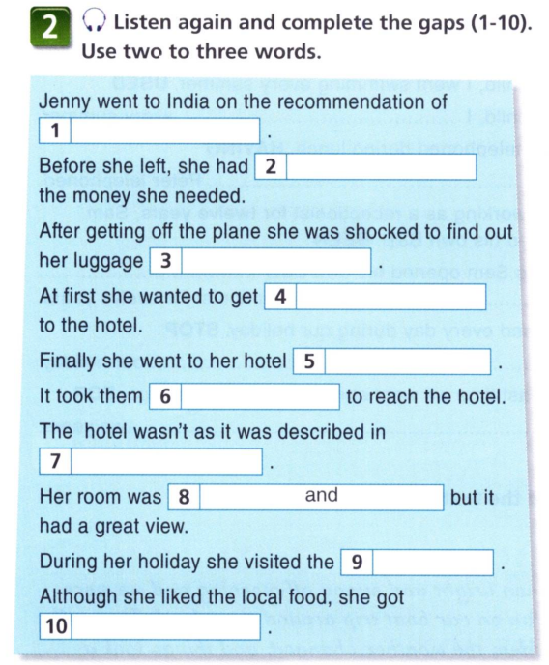
Post-listening:
Work in pairs. Discuss the problems which you have faced while travelling. Use prompts. (4m)
- Have you ever had a problem while on holiday?
- Where were you?
- Who were you with?
- What exactly happened?
Homework (1m)
Interview your friends and/or relatives about holiday problems which they have experienced. Prepare results in a chart using Diagram Generator AI

Assessment and evaluation (3 min)
Before we finish, let’s think about what you’ve learned today.
Please complete these short sentences:
- Today I learned that travelling can…
- The most useful word or phrase I learned is…
- The most interesting part of the lesson was when…
- One problem people can face on holiday is…
- I feel more confident now using phrases like “What an awful experience!” because…
- I found it difficult to…
- Next time, I’d like to practise more…
- Using AI today helped me to…

